Monitoring Tools

**Overview:**

* Nagios
* Cloudtopus
* AWS CloudWatch
* Htop
* Visualping
* Freshping

# Nagios

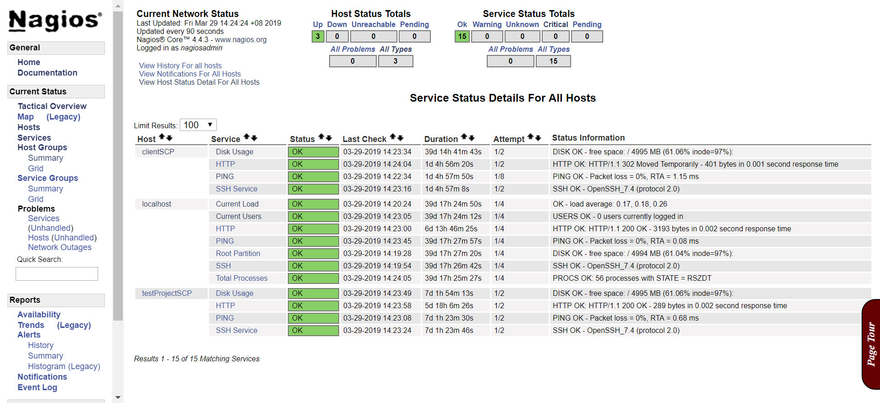

# Cloudtopus

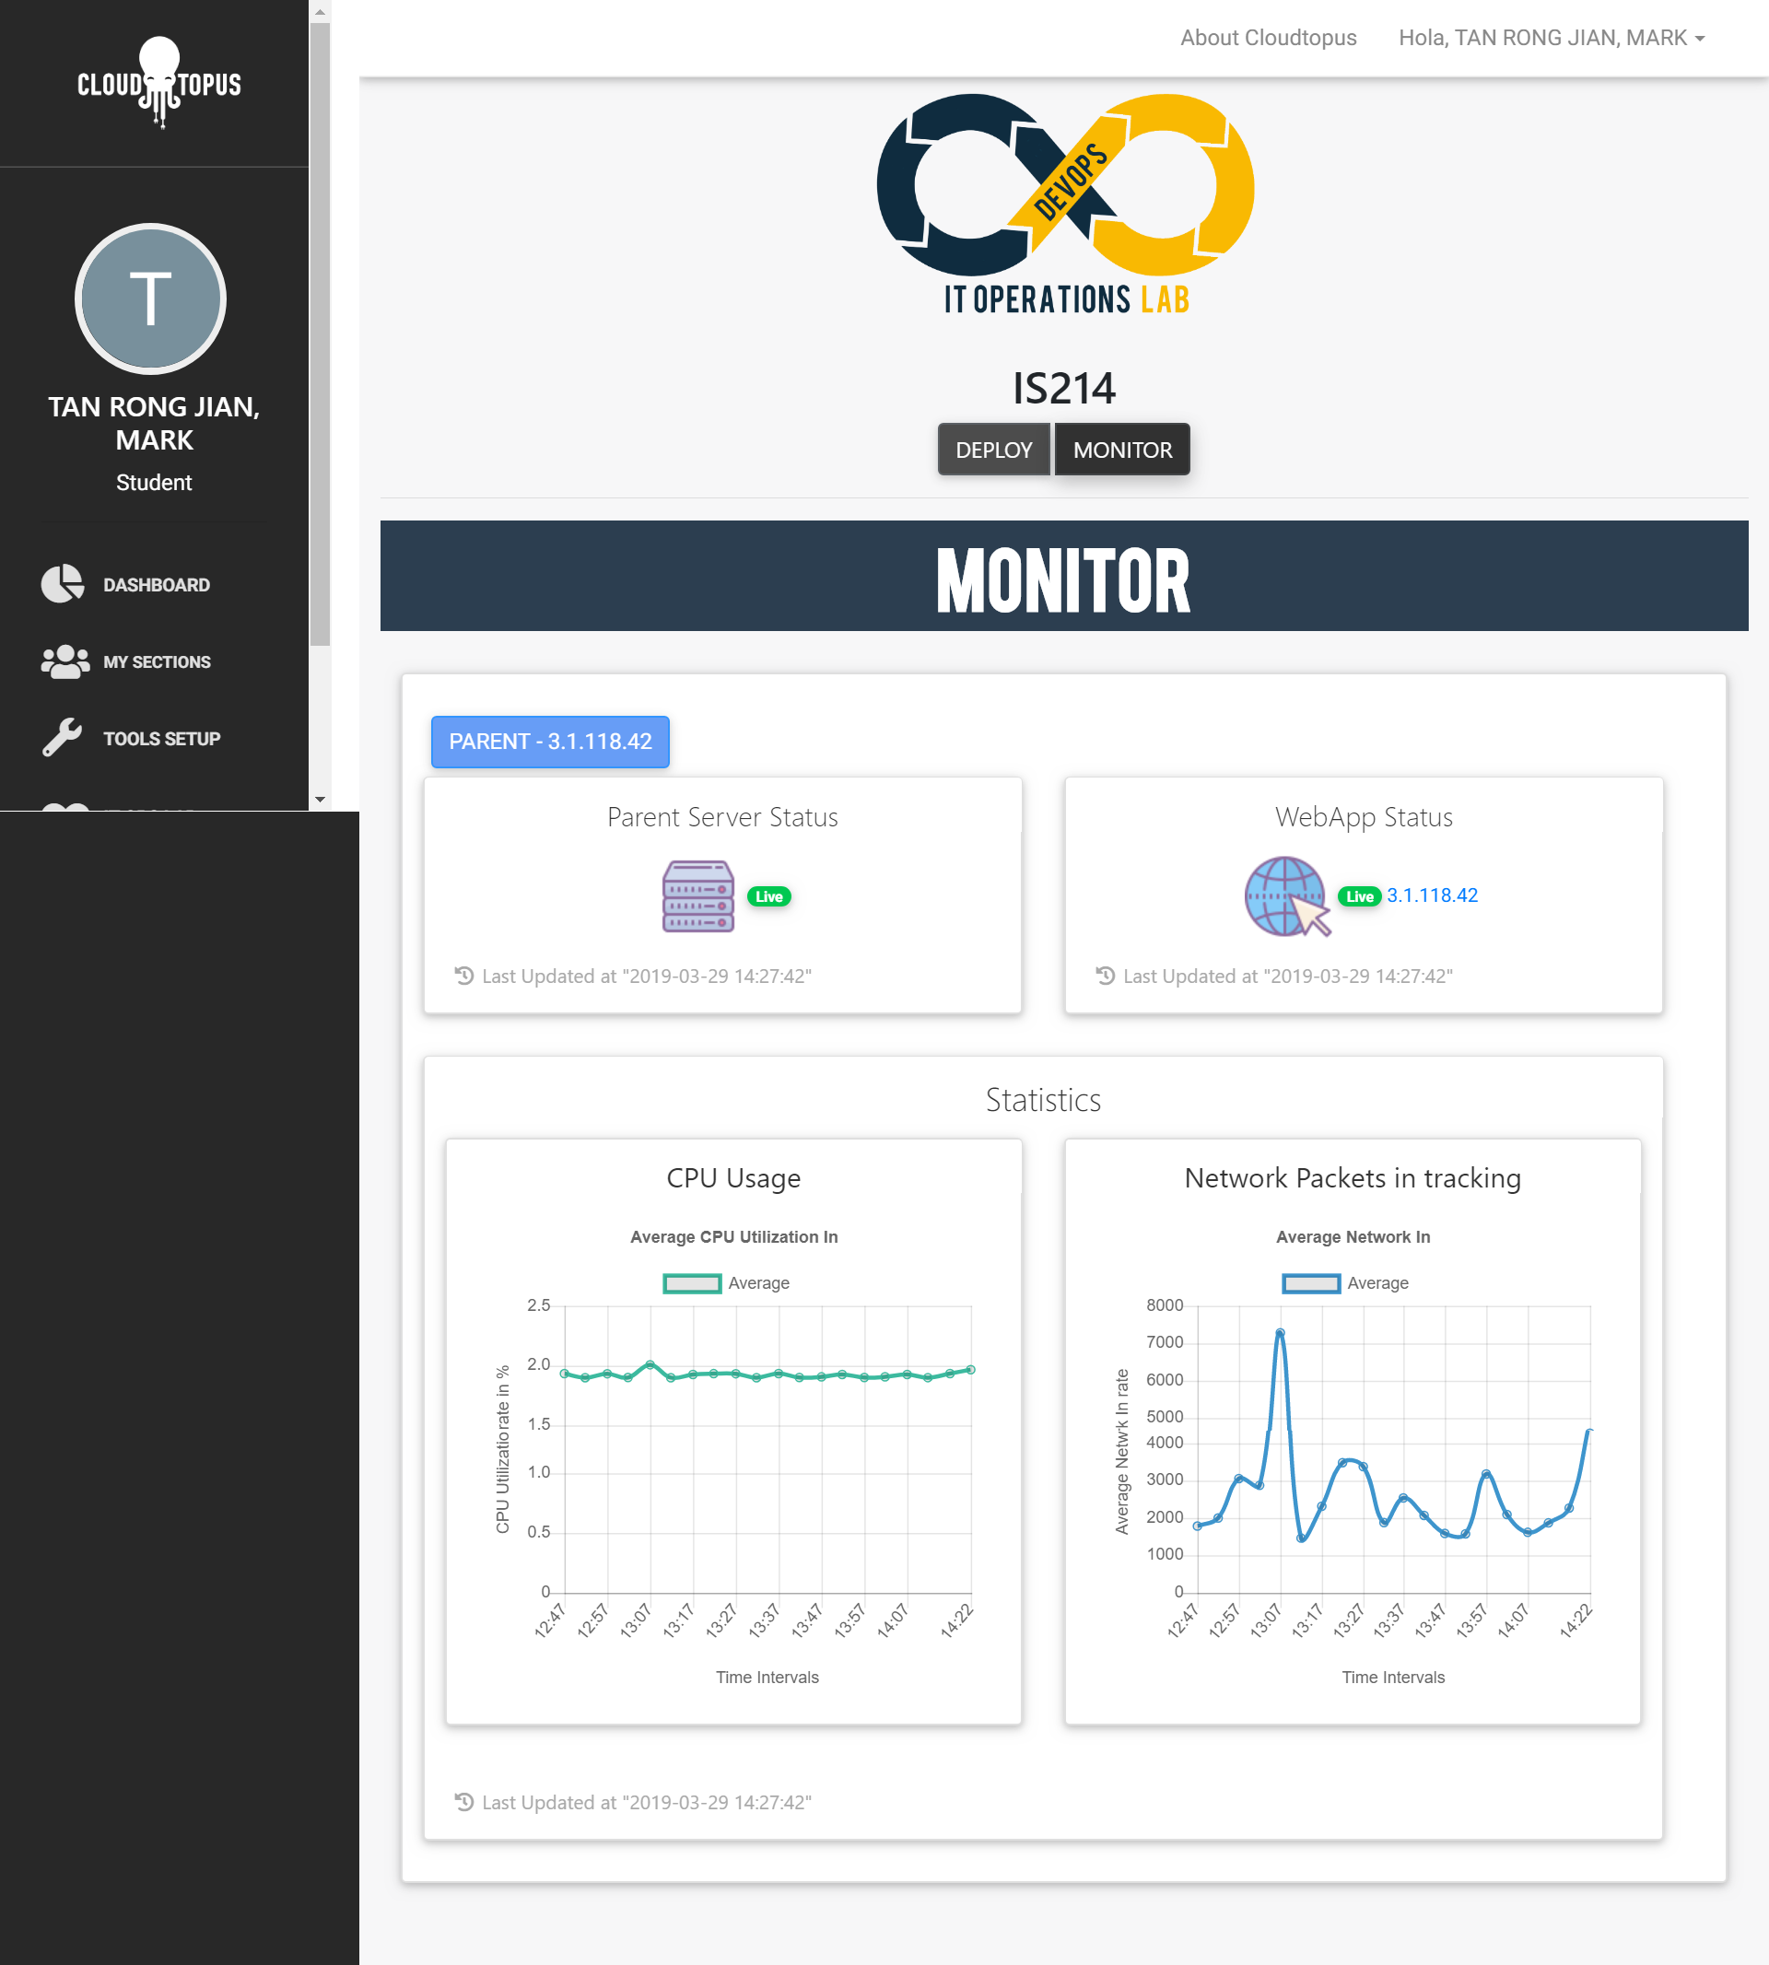

# AWS CloudWatch

## CloudWatch: Overview

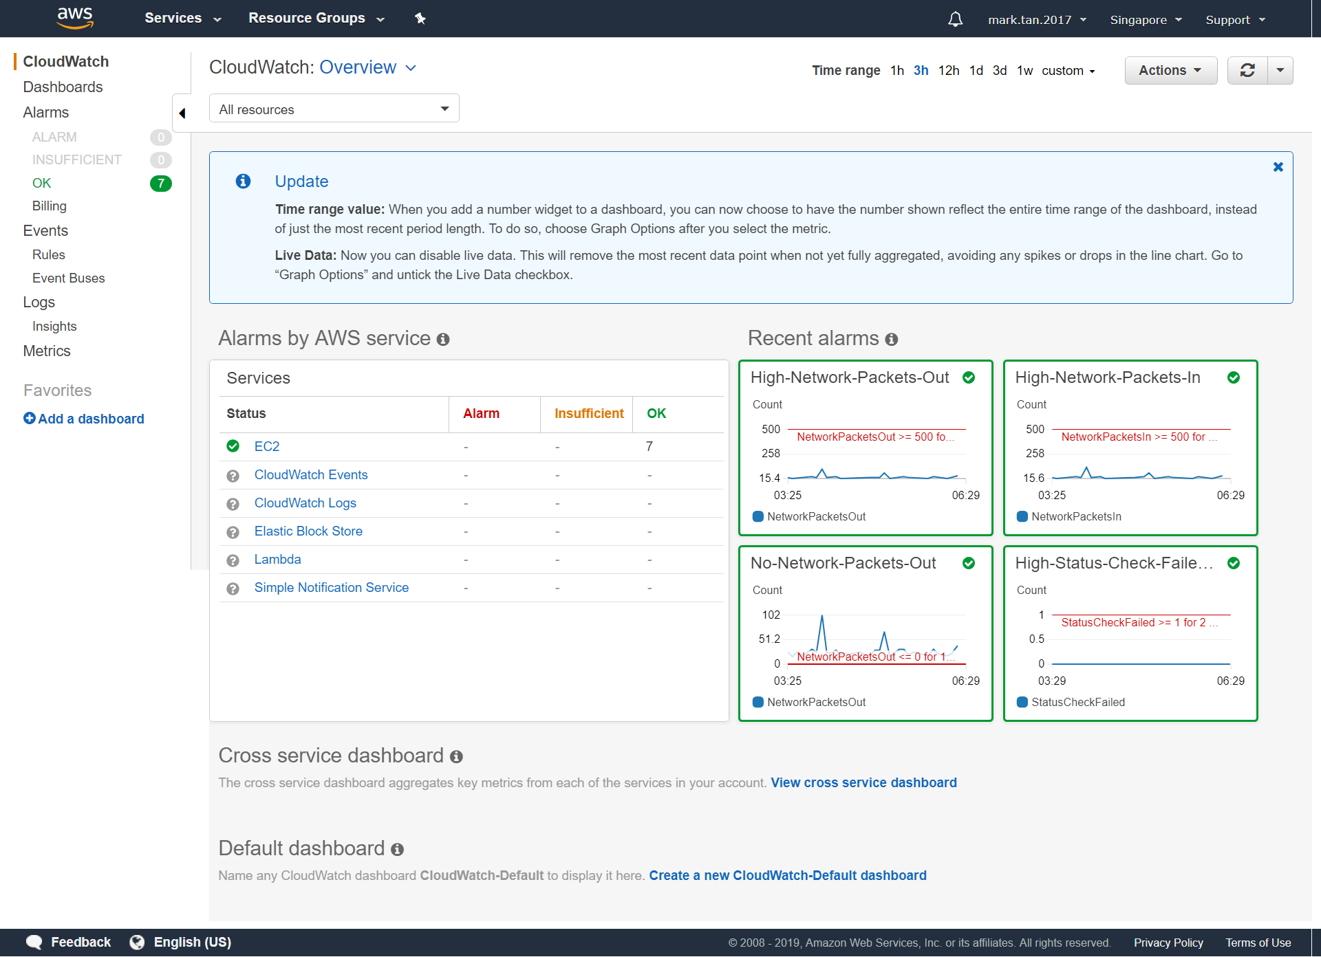

## CloudWatch: Alarms

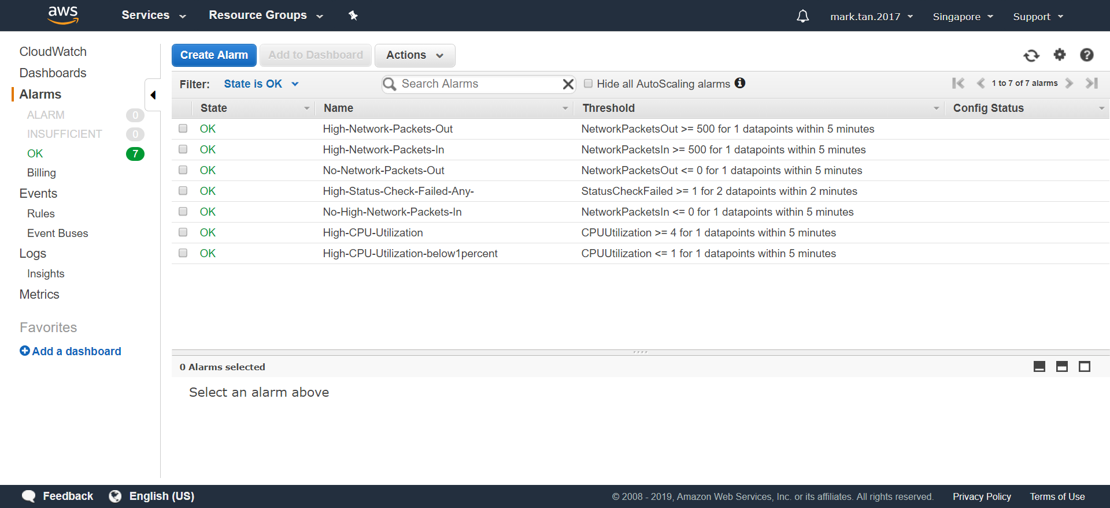

## CloudWatch: EC2 Set Alarms

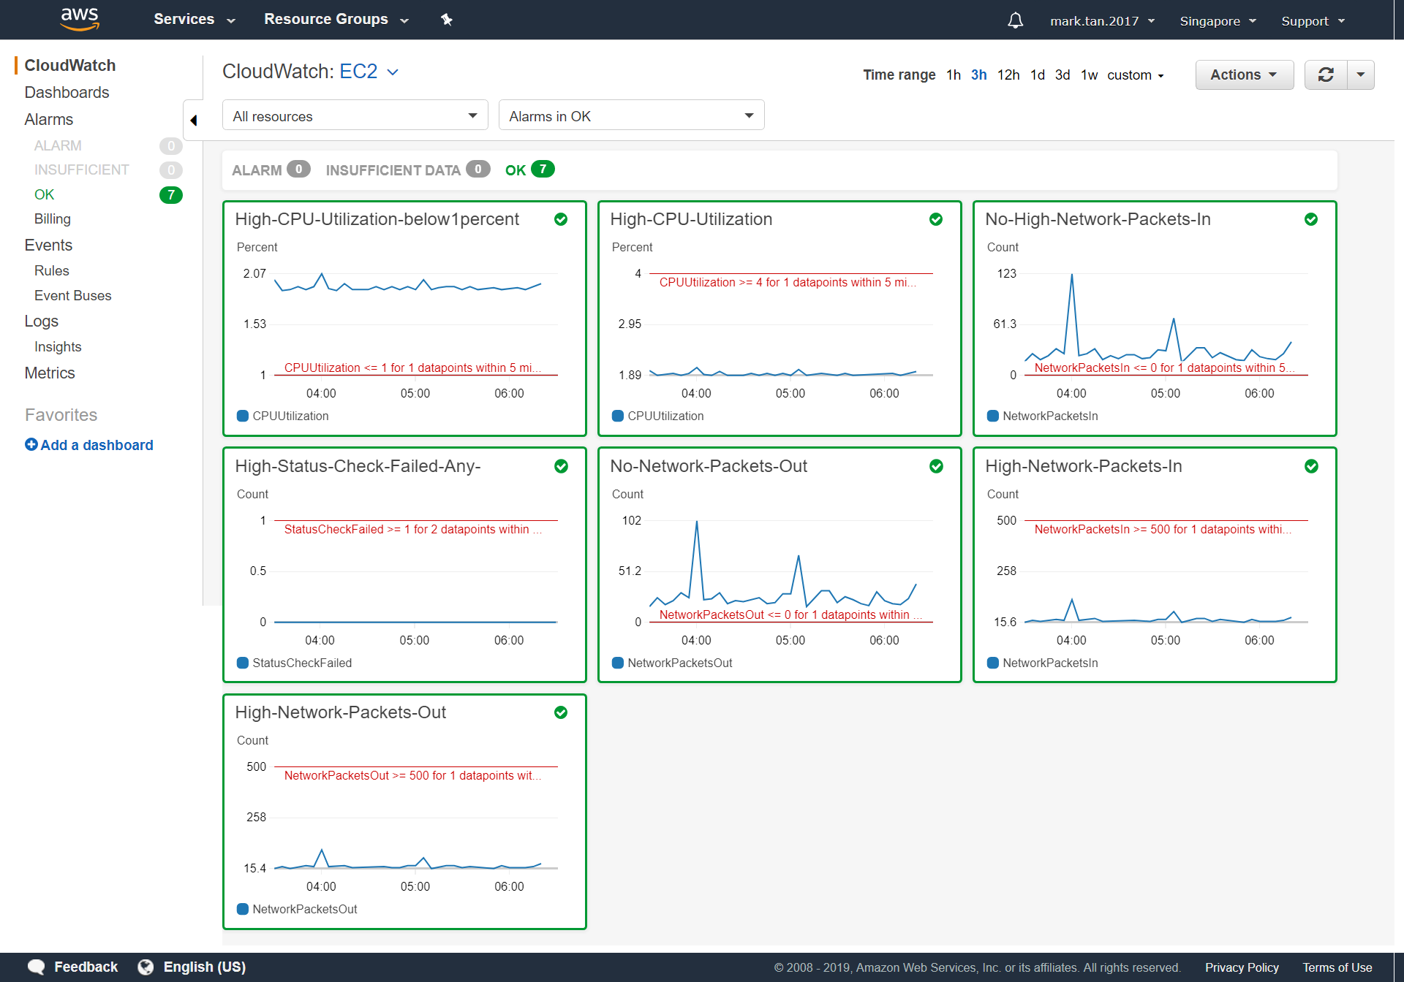

## CloudWatch: EC2 All Statistics

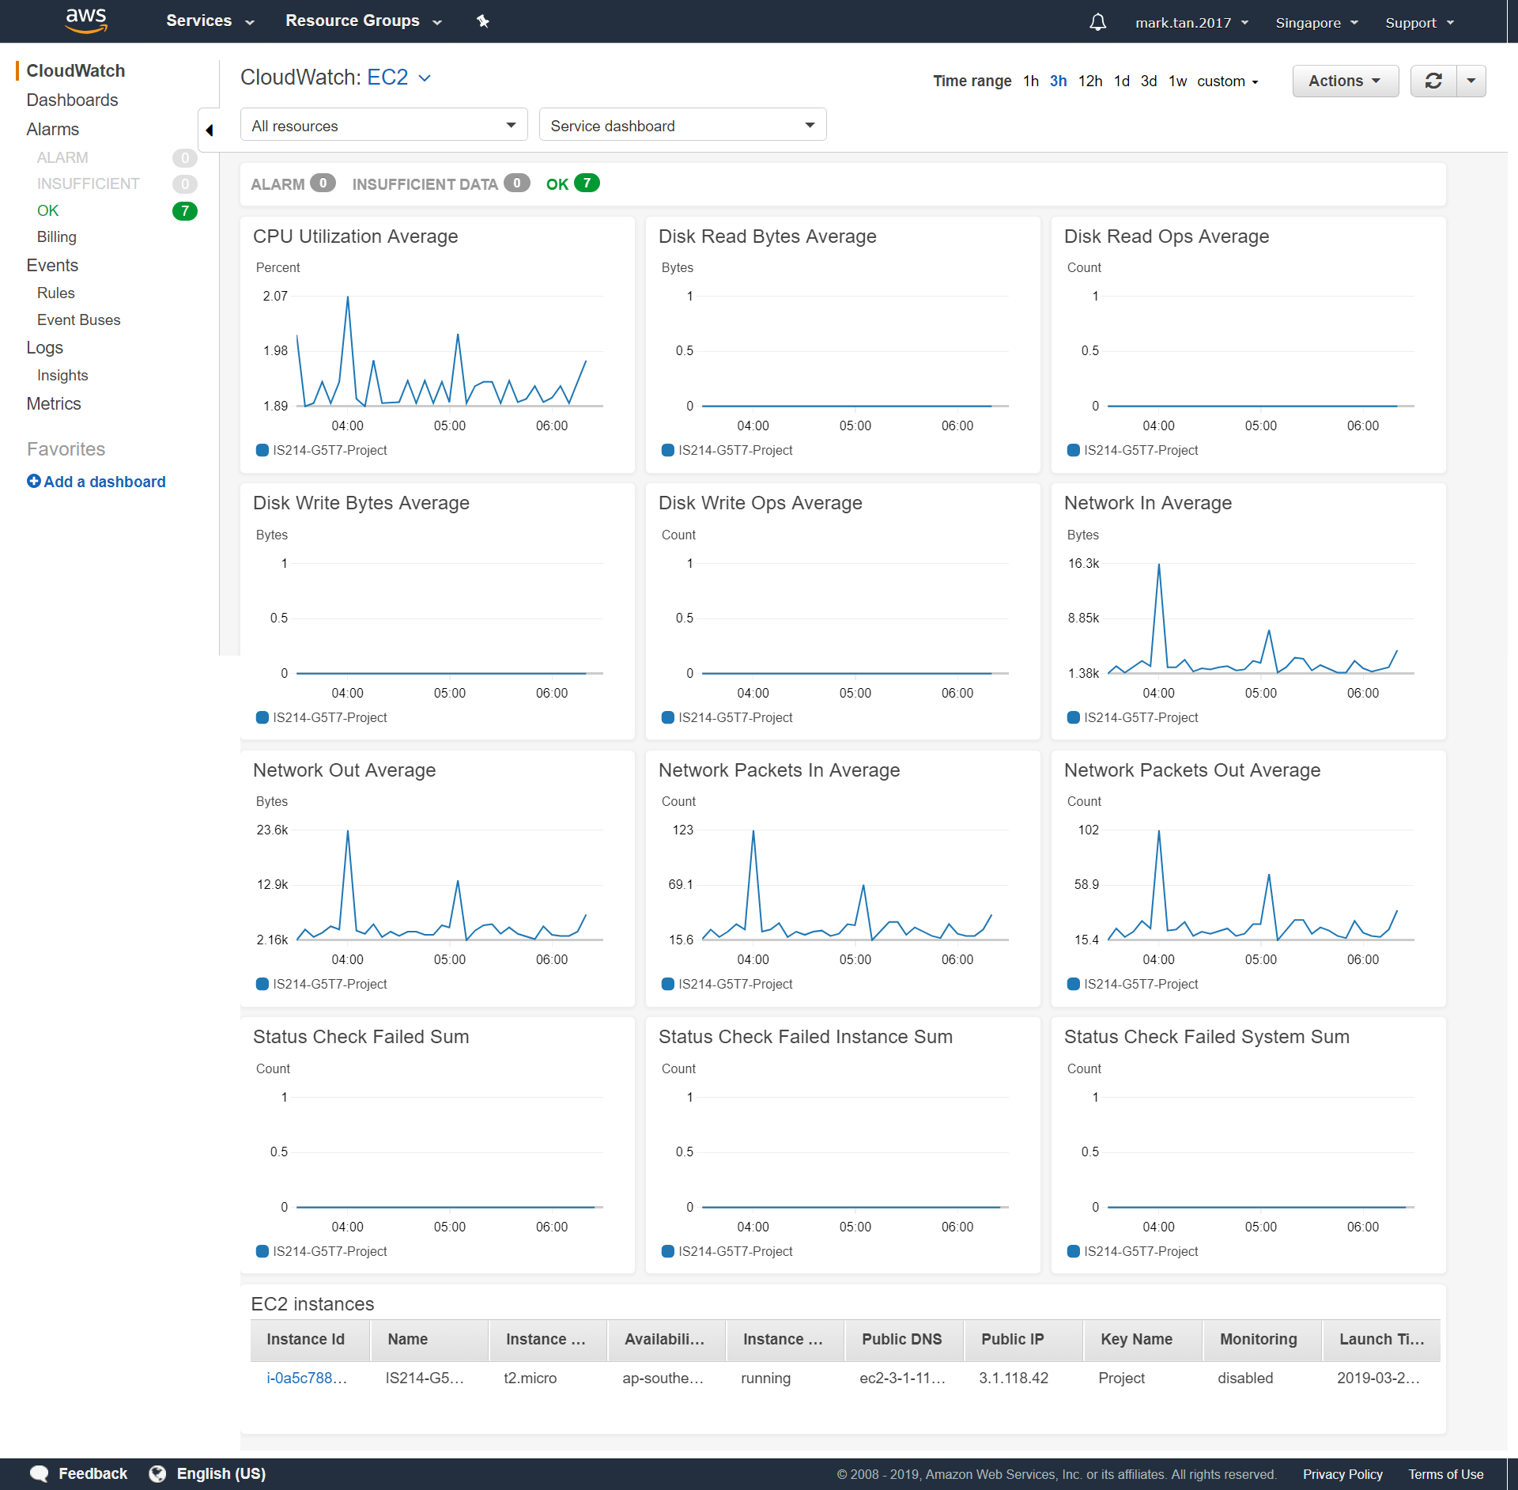

# htop

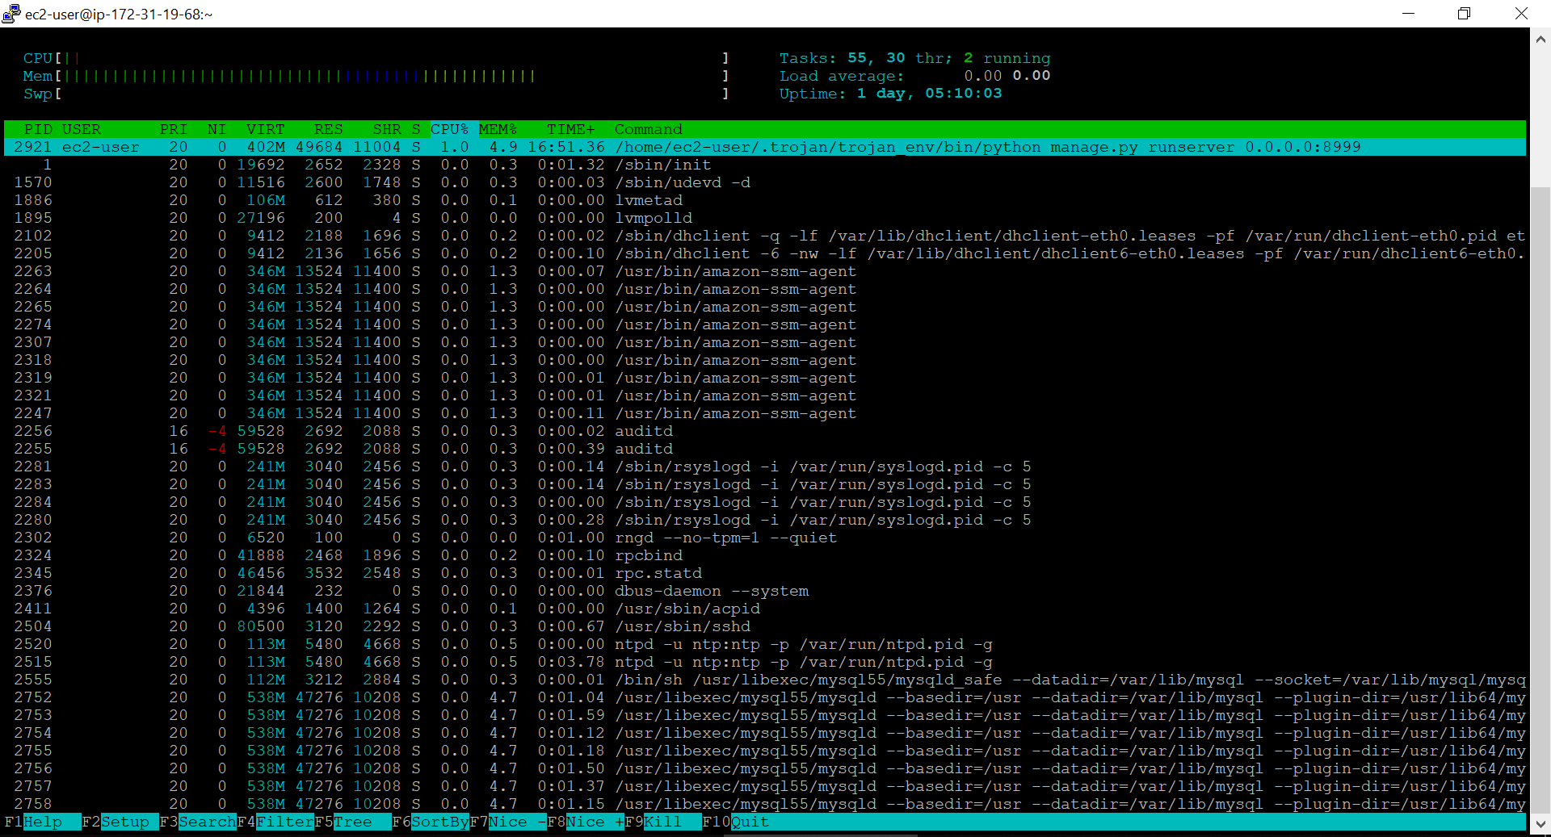

# VisualPing

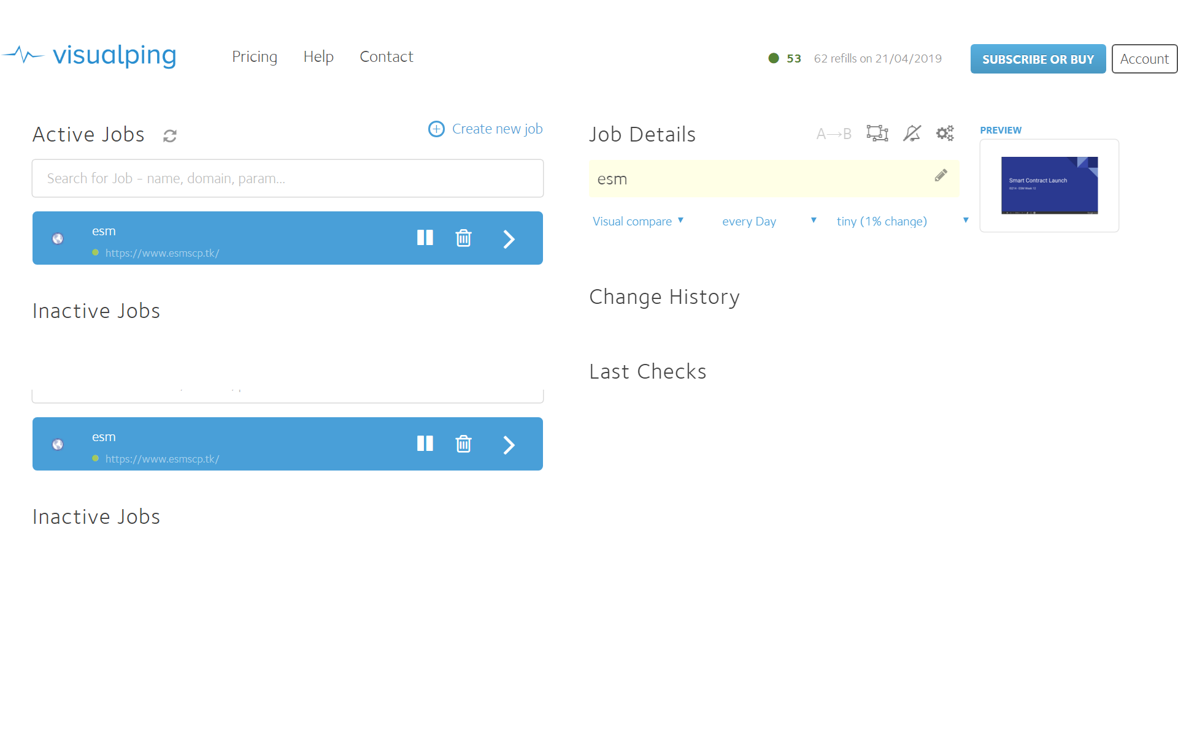

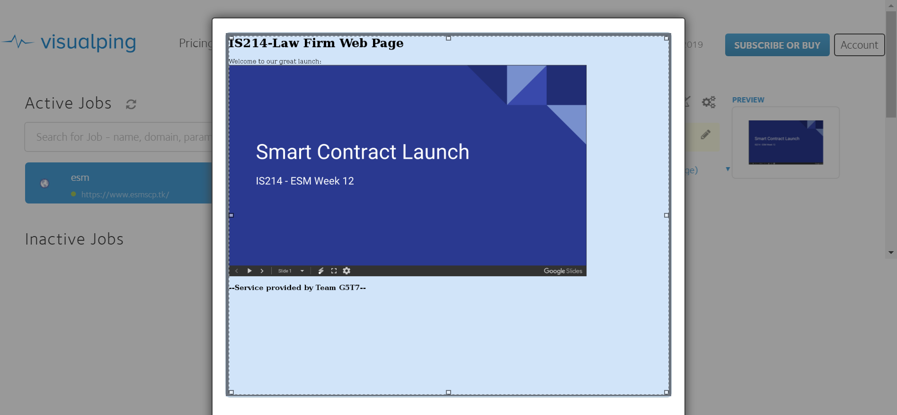

# Freshping

## Freshping: Dashboard

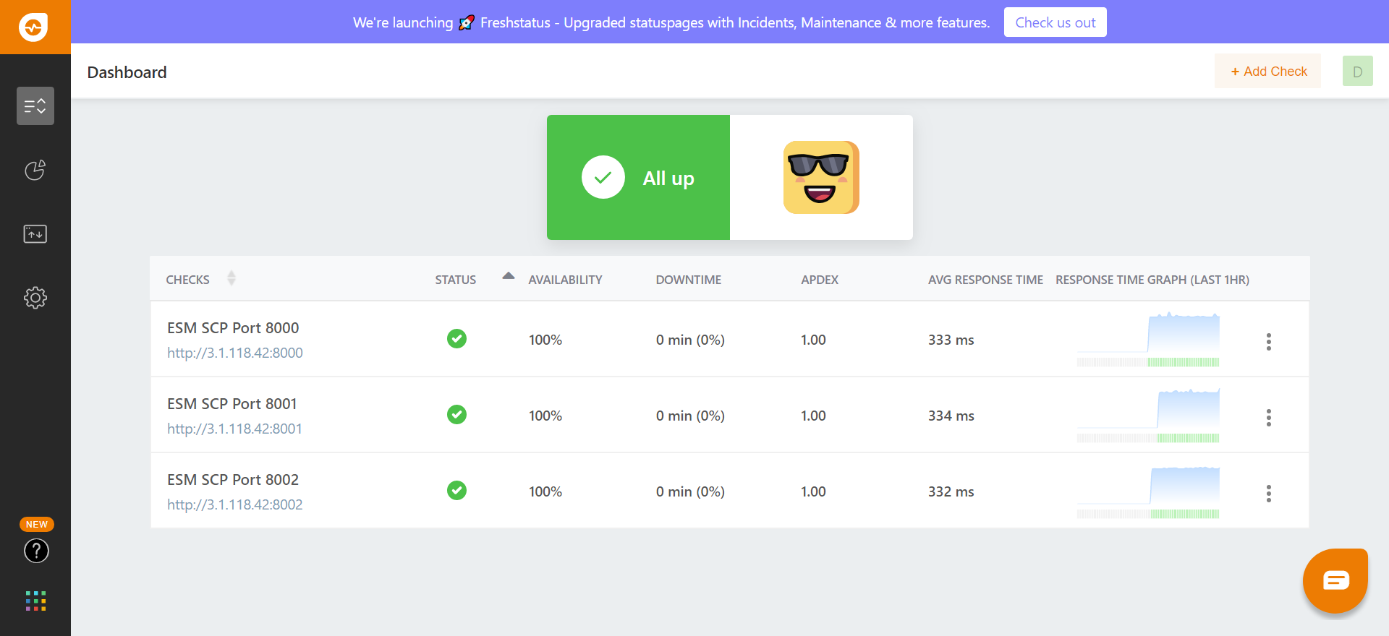

## Freshping: ESM SCP Port 8000

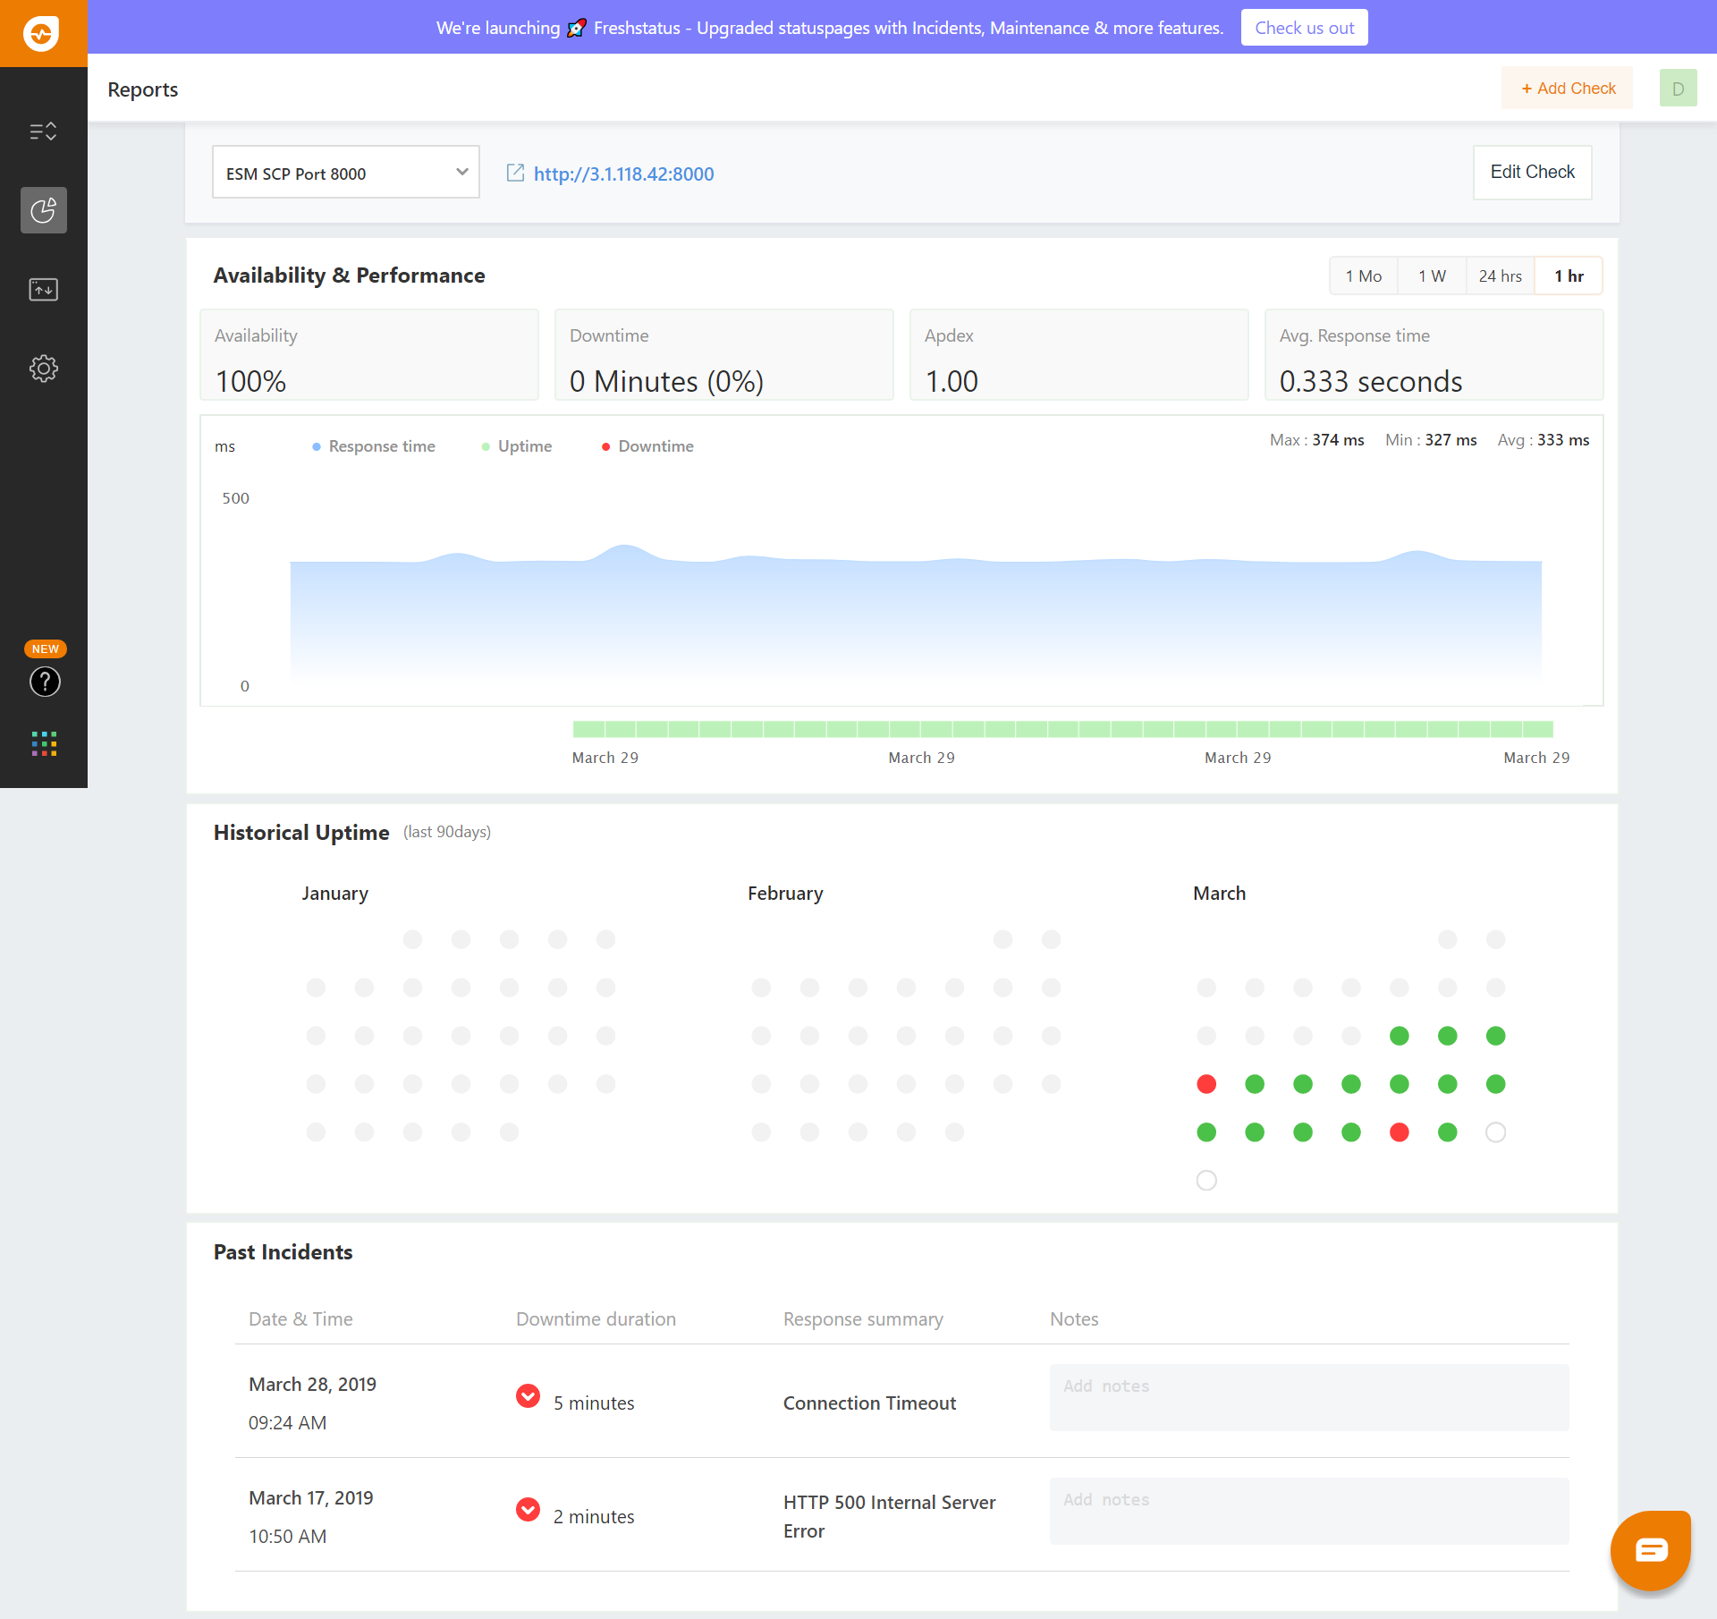

## Freshping: ESM SCP Port 8001

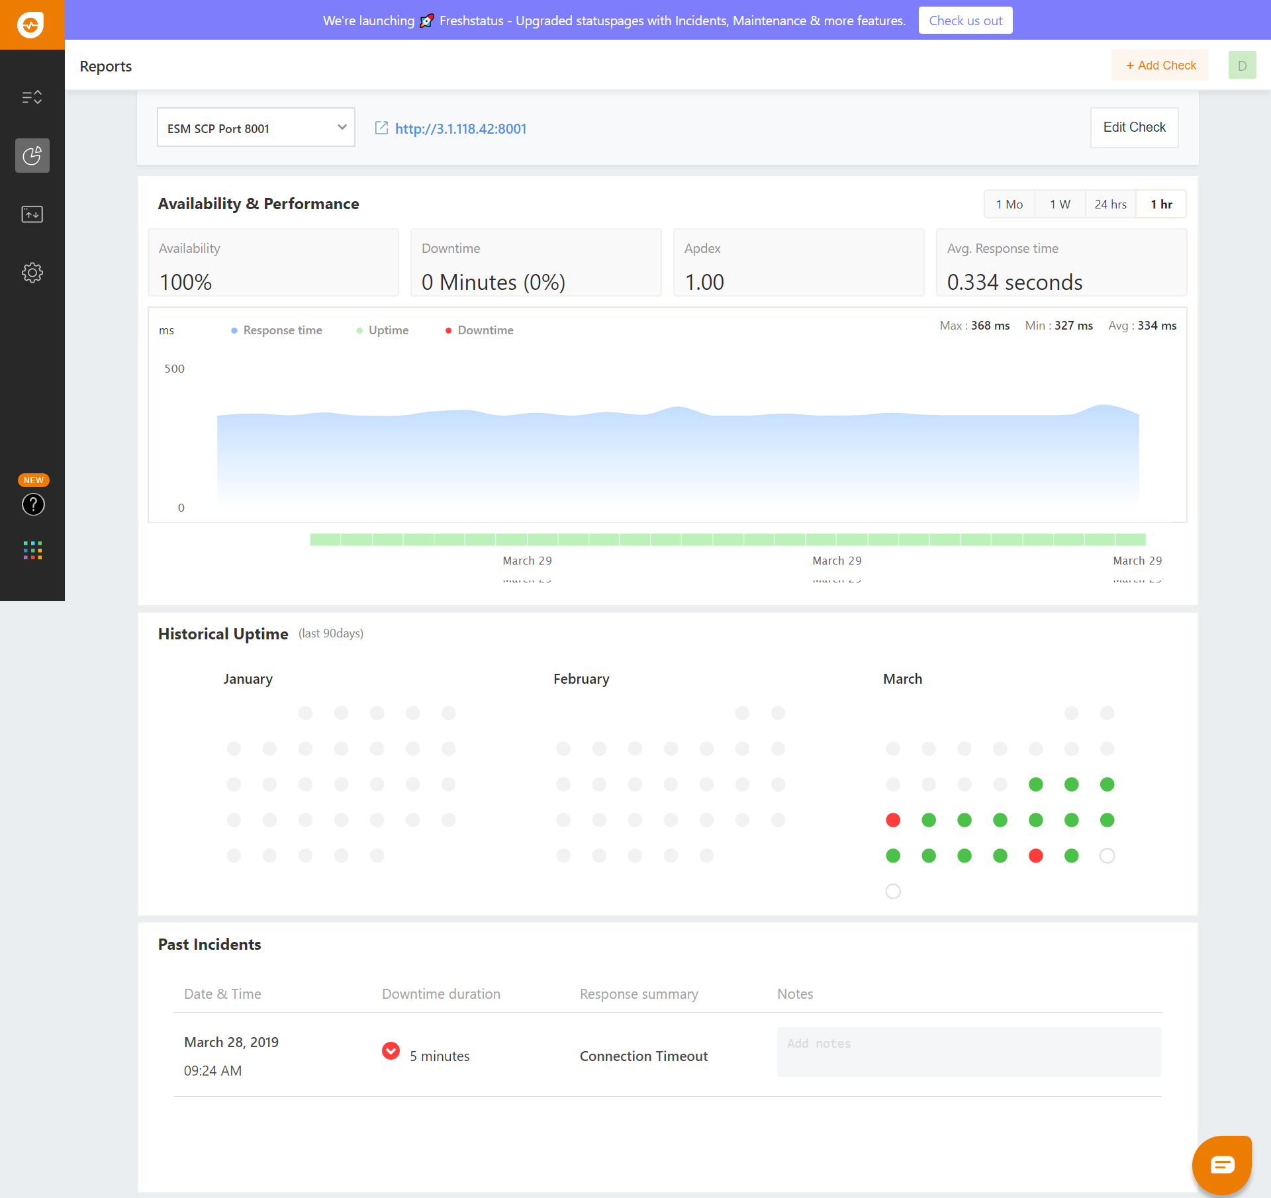

## Freshping: ESM SCP Port 8002

